intro:
interface between user and hardware
resource allocator and manager

processes require two types of time: 1. cpu time 2. i/o time.

batch os : fifo was used so very less efficiency

multiprogramming : if a job is waiting for i/o then the cpu will start executing next job.

multitasking: extension of multiprogramming. if job j1 j2 j3 j4.. then cpu will be executing all the jobs one by one for fraction of seconds which feels like it is executing all at the same time. (multiprogamming with pre-emption(means switching to next process before completing first forcefully) is multitasking).

multiprocessing: lots of cpus.. parrallel execution of many processes.
realtime os: soft real time and hard real time.

process management:

a.out - executable file contains machine code. which os executes..
static variable lifetime is till the process is alive.
heap grows upwards. and stack grows downwards.

attributes of process:
1.process id
2.program counter-- to keep the track of which instruction to execute next
3.process state
4.priority
5.general purpose registers : when process switches from one to anothen. state of register is also stored which will resume when the first process comes back again

6. list of open files
7.list of open devices
8.protection

***pcb(process control block)(context)***
pcb is used to store eveything about the process helps when process switching takes place

states of a process:
1.new(secondary memory sm or just coming to mm)
2.ready(mm)
3.run(mm)
4.block and wait (may be in case of waiting for i/o)(mm)
5. termination or completion
6.suspend ready(sm)
7. suspend wait or block(sm)

operations on processes:
1.creation
2.scheduling
3.executing
4.killing/delete

MULtiprogramming types:
1.pre-emptive (means switching to next process before completing first forcefully)
2. non-preemptive(cpu doesnt force the process to get out of cpu for next process)

minimum states process goes through is 4.

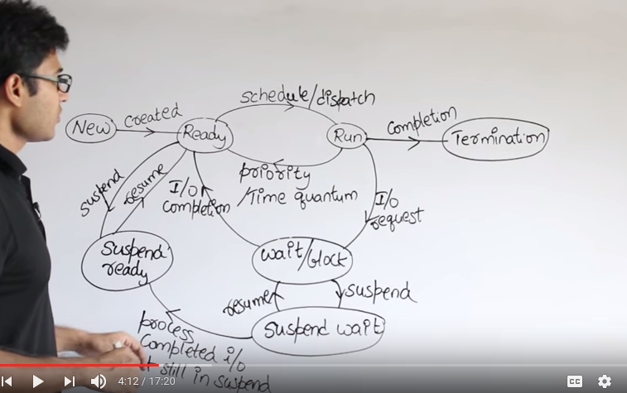

I/o can also be done in when the process is in secondary memory (kinda fishy).

Scheduler:
long term scheduler (most effect): how the process are schedular so that there wont be too much waste of time like if all the huge processes require I/o shouldnt be send altogether.

short term scheduler(which process is execute next) – dispatcher does the context switching after short term scheduler tells it too..
medium term scheduler: effects in swapping of process between sm and mm.

Arrival time: is the time at which process arrived
burst time(imaginary): is the time that process will take to complete
completion time: the moment at which process is completed
turn around time: total time spent by the process(completion time – arrival time)
waiting time: total time process was waiting ideally(turn around time – burst time)
response time: the time (first time scheduled time – arrival time)

these can be asked
avg turn around time of all the processes, avg waiting time

video 9: convey effect(starvation)
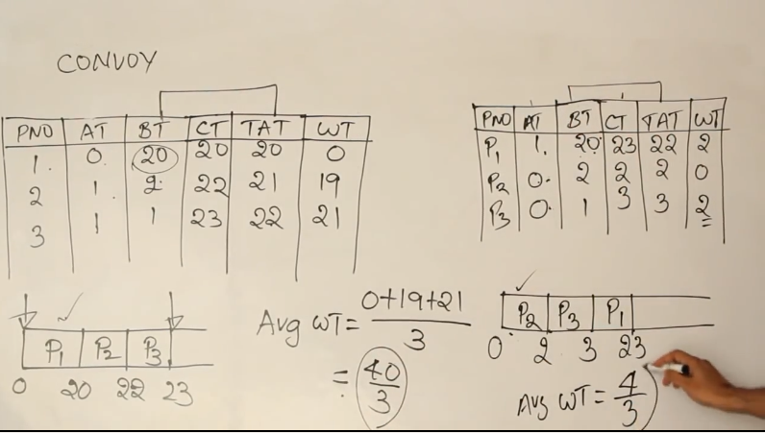
in fcfs if the large burst time process arrives first then all the other process starve which leads to larger
avg waiting time. This is convey effect.

Video 10: fcfs done

video 11: fcfs with overhead

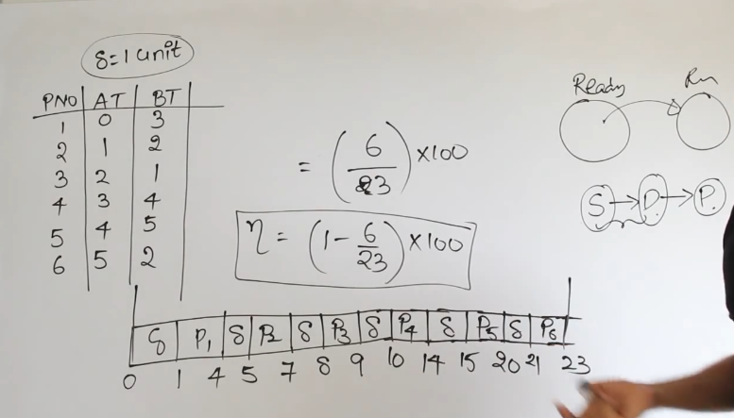

video 12: sjf shortest job first.
1. non-preemptive :

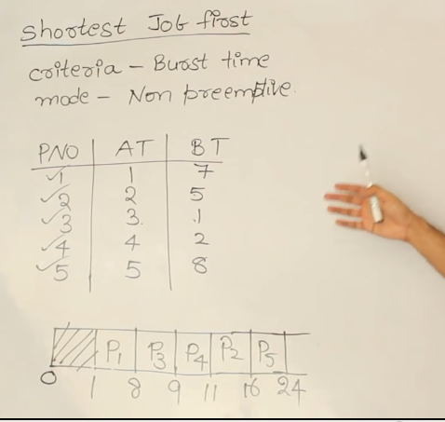

Mean heap is the data structure used for this scheduling

sjf can also lead to convey effect. Because it only takes the shortest job among the ones available at that moment.

Sjf is hard to implement since we dont know the burst time of processes before executing them.

Throughput = no of processes finished per unit time

sjf has the highest throughput among all other processes

#ravindrababu lecture 14 to resume from start

